Banking Laws & Practices—An Overview
- Significance/Importance of Law
Law is to maintain rights, uphold justice and redress wrongs. Law ensures public order, balance, harmony, peace and tranquility amongst the persons within the state and inter-states.
Law---Defined
- Law signifies a rule of action and is applied to all kinds of action.
- We are familiar with laws of nature, laws of mechanics. We are also conversant of laws of honor, laws of morality, law of God.
- We are also listen about:
  - Criminal Procedure Code. (Cr PC)
  - Civil Procedure Code (CPC)
  - Contract Act.
  - Banking Companies Ordinance
  - Sales Tax Act
  - Companies Ordinance etc.
  - Above are statutory enactments enforced by Courts of law, in a system/society.
  - Hence law denotes entire body of legal principles prevailing in a particular system/society.

Some Concepts of Law:
- “Law is not right alone or might alone, but a perfect combination between two.”
(Salmond)
- “Law is the command of sovereign containing a common rules of life for his subject and obliging them to obedience”
(John Erskin)
- “Coercion is a weapon of law which law has forged, but it is not the basis of law”
(De Motmorency)
- “ Law is the body of principles recognized or enforced by public or regular tribunals in the administration of justice”
(Pound)
- “ Law is the system of rights and obligations which the state enforces”
(Green)
- “ You will not mistake my meaning or suppose that I depreciate one of the great human studies if I say that we cant learn law by learning law. If it is to be any thing more than just a technique it is to be so much more than itself, a part of history & sociology, a part of ethics and philosophy of life”
(Lord Radcaliff)
Classification of Law:
- Imperative Law:
- Three Essentials
- General rules
- Some authority behind this law.
- It must be enforced by superior power.
- Physical or Scientific Law:
- Laws of motion, Gravity, Astrology
- Moral laws
Law of morality, divine law.
- Conventional Law
Based on agreements of interacting parties enforced at court of law e.g. Contract, Memorandum of Association.
- Customary Law.
Rules, Customs followed for a long time.
- Practical or Technical Law.
Law of engineering, architecture, photography.
- International law
Rules, which govern sovereign States in their relations’ and conduct to one another.

Distinction Between Question of Law and Question of Fact
- Criminal offence Versus Civil Liability.
- Crime is an offence prohibited by law e-g; tress passing, theft, Murder etc.
- Civil liability arises out of breach of obligations e-g; breach of contract.

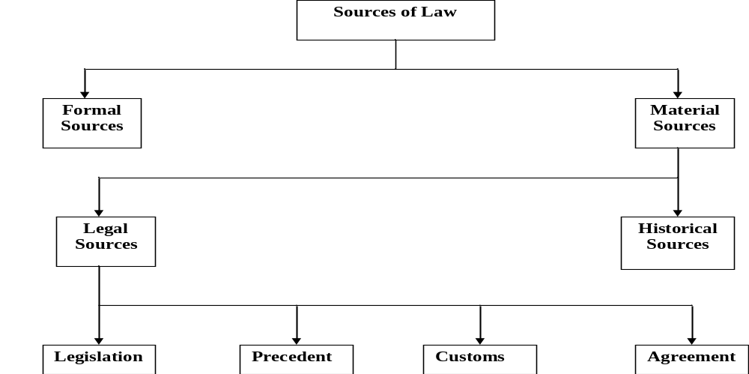

The Characteristics of State:
- Certain Territory
- Certain Functions
- Some Population
- A Political Society (must have a constitution)
- A Government

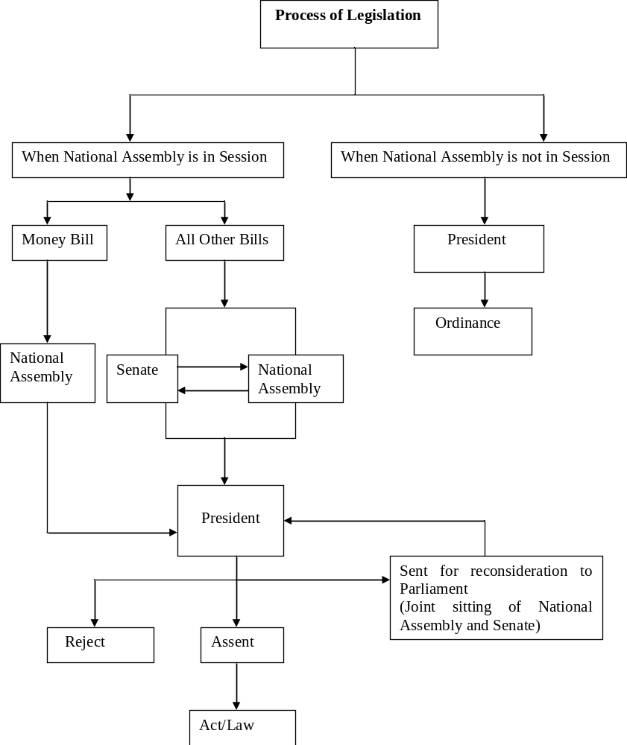

Substantive Law v/s Procedural Law
Substantive Law
- Substantive law defines rights.
- This branch of law concerns the purposes and subject matter of litigations.
- It is concerned with the objects of administration of justice.
- Its rules govern the conduct of the parties to the matter litigated.
- Its relates to matter outside the courts.
Procedural Law
- It determine the process for remedies or procedure for enforcement of rights in courts.
- It governs the process of litigation or relates to actions or proceedings, civil or criminal.
- It means through which ends of justice are attained.
- Procedural law govern the relations between court and litigants.
- It deals with affairs in the courts.
Sources of Law in Sharia
- Al-Quran
- Sunnah
- Ijtehad
Ijtehad---is the process for ascertaining the law. It is the use of intellectual exertion by an Islamic Jurist. (Mujtahid) to derive an answer to a legal question.

Rules for Exercising Ijtehad:
- It must not be exercised on certain matters (for example, the existence of Allah)\
- Mujtahid must be suitably qualified.
- Recognized methods of Ijtehad to be followed by mujtahid.
Recognized Methods for Exercising Ijtehad
- Ijma---is consensus of opinion based on consultation among Islamic Jurists (Imam, Faqeeh)
- Qiyas---is analogical deduction. It is comparison of two situations with a view to evaluating one in the light of the other.

